# Implement a MapReduce program to process a weather dataset

**Steps:**

1. Open command prompt and run as administrator Go to hadoop sbin directory

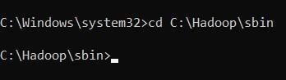

Note:

* 1. Check hadoop/data/datanode and hadoop/data/namenode and if both folders are empty, type “hdfs namenode -format”.
  2. Check python version with “python --version”.
  3. Check “C:\Python39\” is added in Environment variables > System variables

> Path, if not add your python path.

* 1. 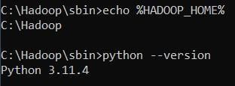Check Environment variables > System variables > HADOOP_HOME is set as “C:\Hadoop”.

1. Start Hadoop Services start-dfs.cmd start-yarn.cmd

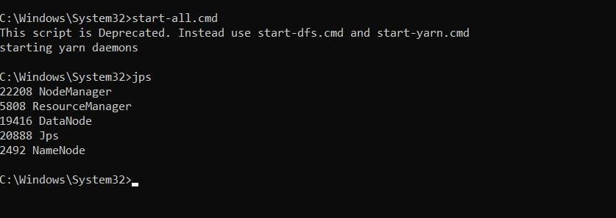

1. Open the browser and go to the URL “localhost:9870”

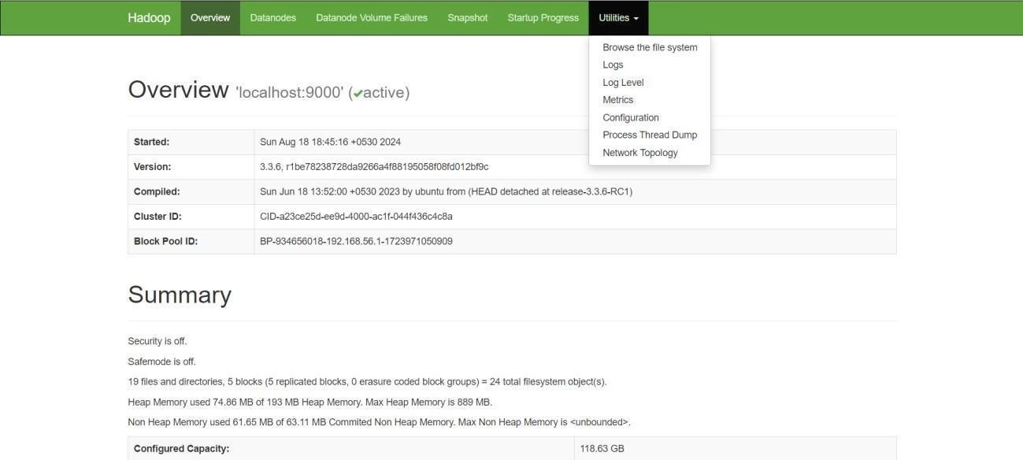

1. Create a Directory in HDFS hadoop fs -mkdir /user/weather

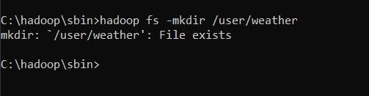

1. Copy the Input File to HDFS hdfs dfs -put

C:\Users\monid\OneDrive\Documents\DataAnalytics\sample_weather.txt /user/weather

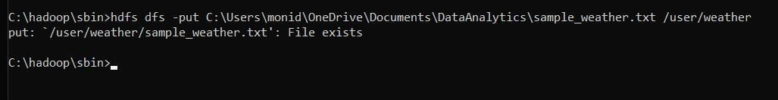

# Note: mapper.py:

#! /usr/bin/env python import sys

def map1(): for line in sys.stdin:

tokens = line.strip().split() if len(tokens) < 13:

continue

station = tokens[0] if "STN" in station:

continue

date_hour = tokens[2] temp = tokens[3] dew = tokens[4] wind = tokens[12]

if temp == "9999.9" or dew == "9999.9" or wind == "999.9": continue hour =

int(date_hour.split("_")[-1]) date =

date_hour[:date_hour.rfind("_")-2] if 4 <

hour <= 10: section = "section1" elif 10 < hour <= 16: section =

"section2" elif 16 < hour <= 22: section

= "section3"

else:

section = "section4"

key_out = f"{station}_{date}_{section}" value_out = f"{temp} {dew} {wind}" print(f"{key_out}\t{value_out}")

if name == " main ":

map1()

# reducer.py: #!

/usr/bin/env python import sys

def reduce1(): current_key = None sum_temp, sum_dew, sum_wind = 0, 0, 0

count = 0

for line in sys.stdin:

key, value = line.strip().split("\t") temp, dew, wind = map(float, value.split()) if current_key is None:

current_key = key

if key == current_key:

|  |  |  |
| --- | --- | --- |
| sum_temp | += | temp |
| sum_dew | += | dew |

sum_wind += wind

count += 1

else:

avg_temp = sum_temp / count avg_dew = sum_dew / count avg_wind = sum_wind / count print(f"{current_key}\t{avg_temp}

{avg_dew} {avg_wind}")

current_key = key sum_temp, sum_dew, sum_wind = temp, dew, wind

count = 1

if current_key is not None: avg_temp = sum_temp / count avg_dew = sum_dew / count avg_wind = sum_wind / count

print(f"{current_key}\t{avg_temp} {avg_dew} {avg_wind}") if name

== " main ":

reduce1()

1. Run the Hadoop Streaming Job

hadoop jar C:\hadoop\share\hadoop\tools\lib\hadoop-streaming-3.3.1.jar ^ -files "/Users/monid/OneDrive/Documents/DataAnalytics/mapper2.py,/Users/monid/One Drive/Documents/DataAnalytics/reducer2.py" ^ -input

/user/weather/sample_weather.txt ^ -output /user/output1 ^ -mapper "python C:/Users/monid/OneDrive/Documents/DataAnalytics/mapper2.py" ^ -reducer "python C:/Users/monid/OneDrive/Documents/DataAnalytics/reducer2.py "

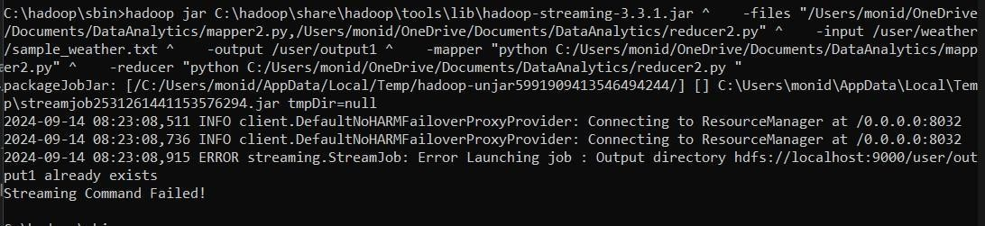

1. View the Output hdfs dfs -cat /user/output1/part-00000

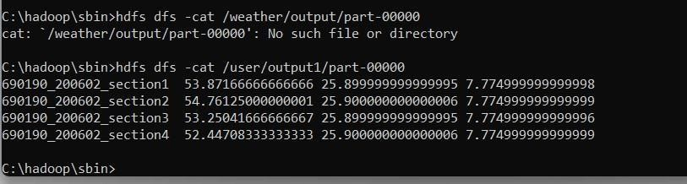

1. Once the map reduce operations are performed successfully, the output will be present in the specified directory.

“/user/output1/part-00000”

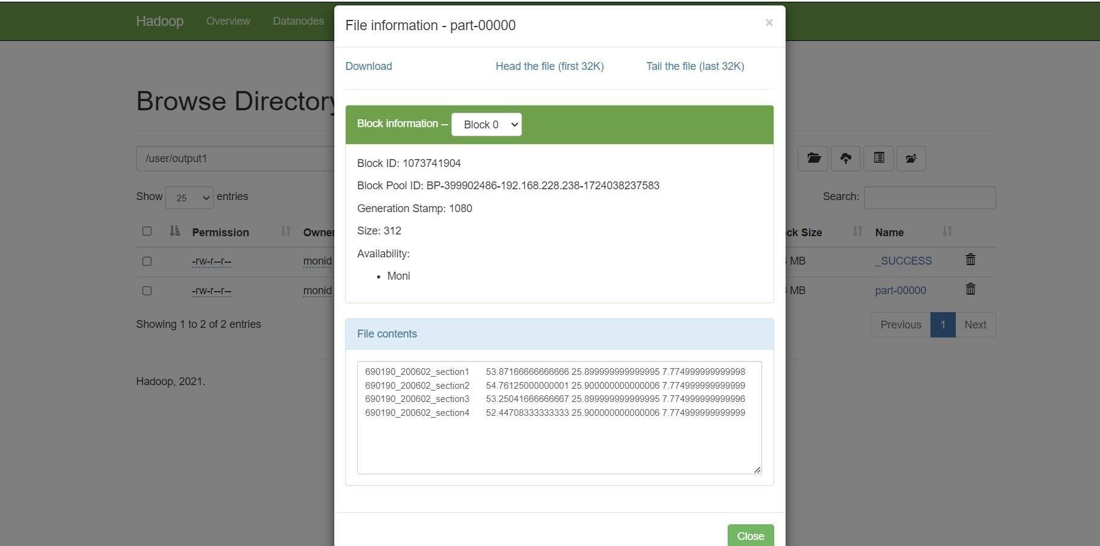

1. Stop Hadoop Services stop-dfs.cmd stop-yarn.cmd

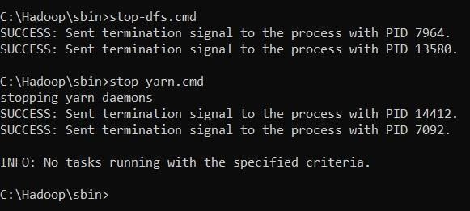

**RESULT:**

Thus the implementation of the MapReduce python program a weather dataset in Hadoop is executed successfully.